**Name: Shreehar Joshi ID: R00730962**

**Q.no.1.**

1. It is a regression problem because the response variable (CEO salary) is a quantitative variable which can have a range of numerical values. The number of observations, n, in this case is 100 and the number of variables, p, in this case is 3 if p refers to only predictor variables and 4 if p is the total number of variables(predictor + response).
2. It is a classification problem because the response variable (outcome of product) is a qualitative variable which can take only two values: success or failure. The number of observations, n, in this case is 25 and the number of variables, p, in this case is 8 if p refers to only predictor variables and 9 if p is the total number of variables(predictor + response).

**Q.no.2.**

1. 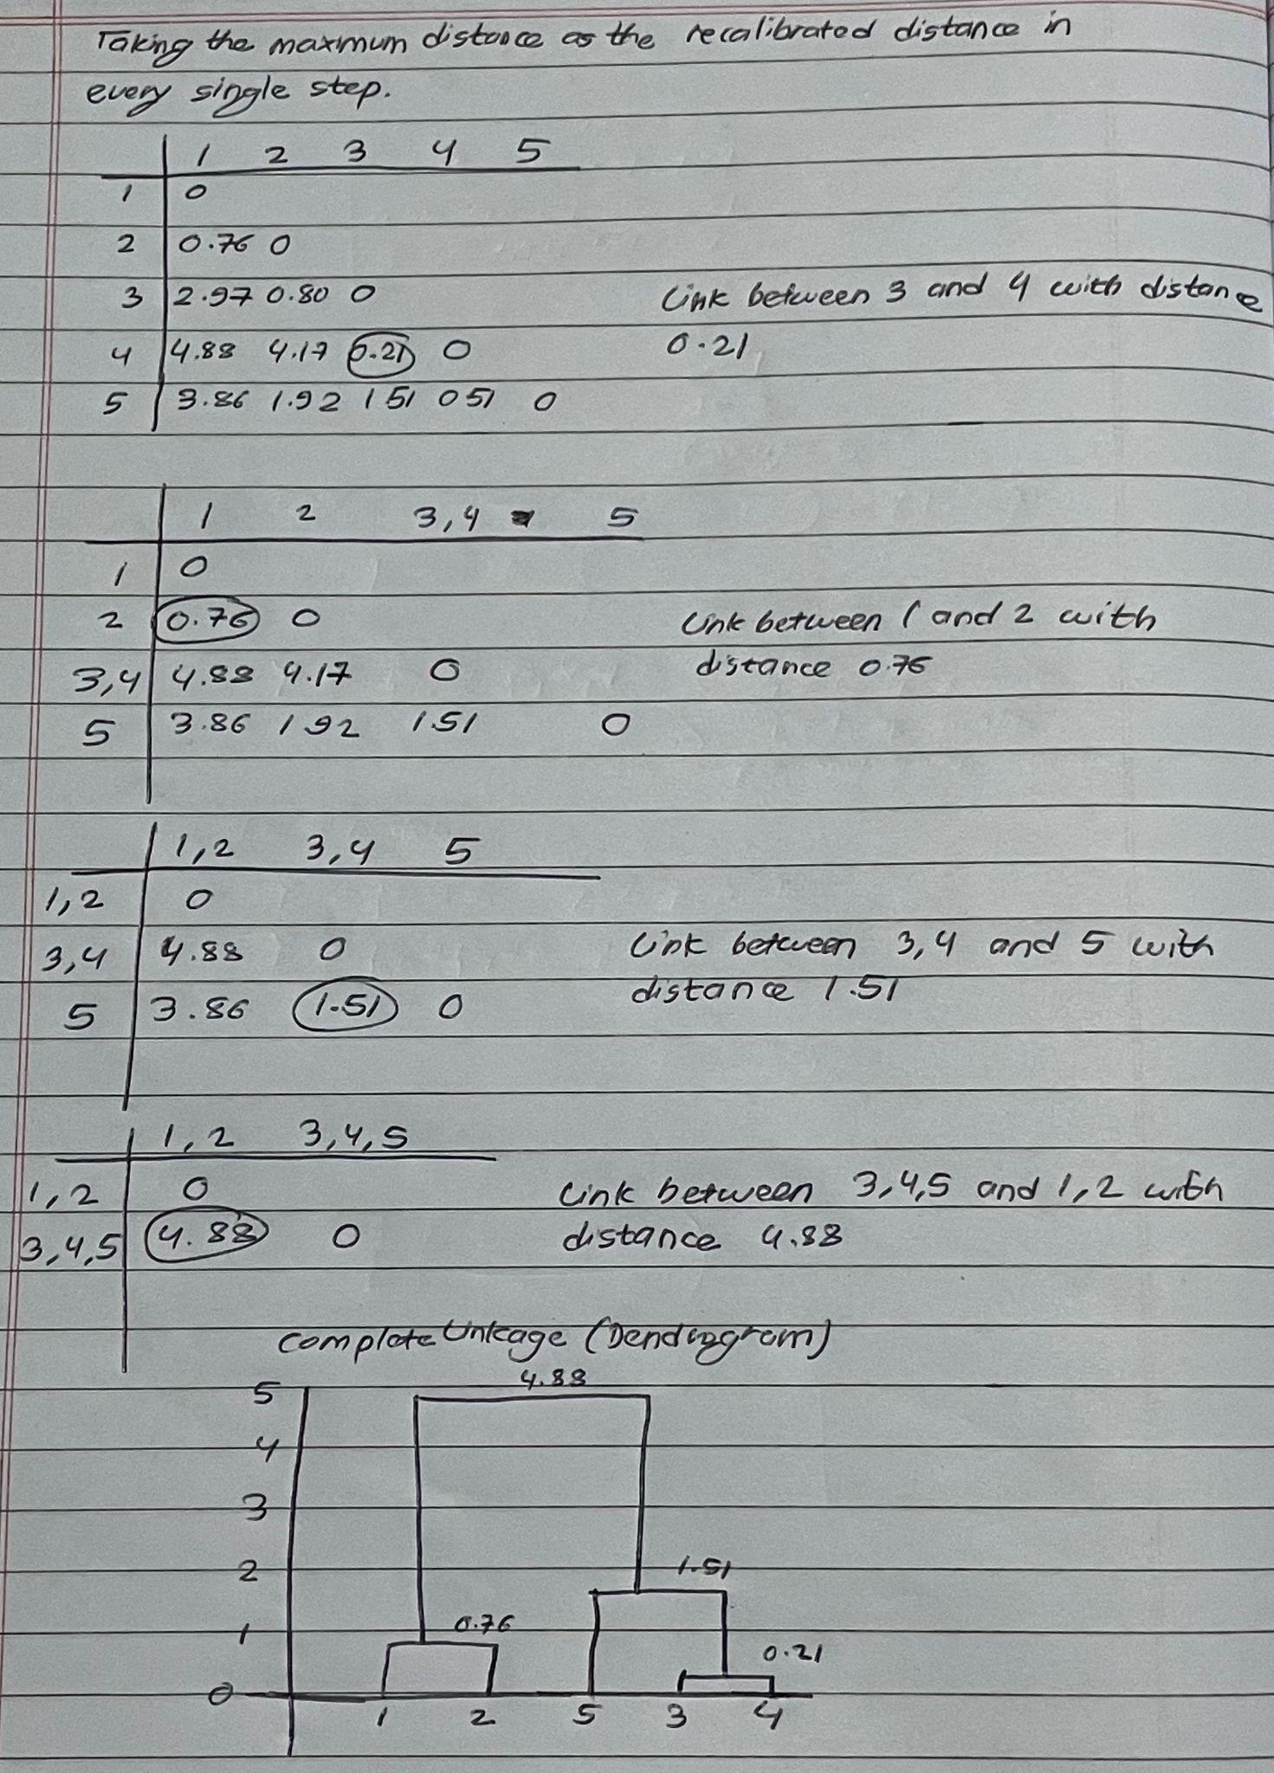
2. The two clusters that form as a result of cutting the dendrogram in (a) consist of 3, 4, and 5 in one cluster and 1 and 2 in another cluster.

**Q.no.3.**

1. The value of N1 = 10 ( Error needs to be found for each group one at a time and there are 10 groups)

The value of N2 = 180 ( 9 groups form the train set every single time and 9 * 20 = 180)

The value of N3 = 20 ( 1 group form the test set every single time, hence size 20)

1. The statement is false. The accuracy that we are concerned about to ensure that the classifier is efficient in the real world is the test accuracy and the second classifier has higher test accuracy than the first classifier. Hence the second classifier is a better classifier than the first. The first classifier is simply overfitting in the training data as a result of which it was able to show 100% accuracy in the train data.
2. 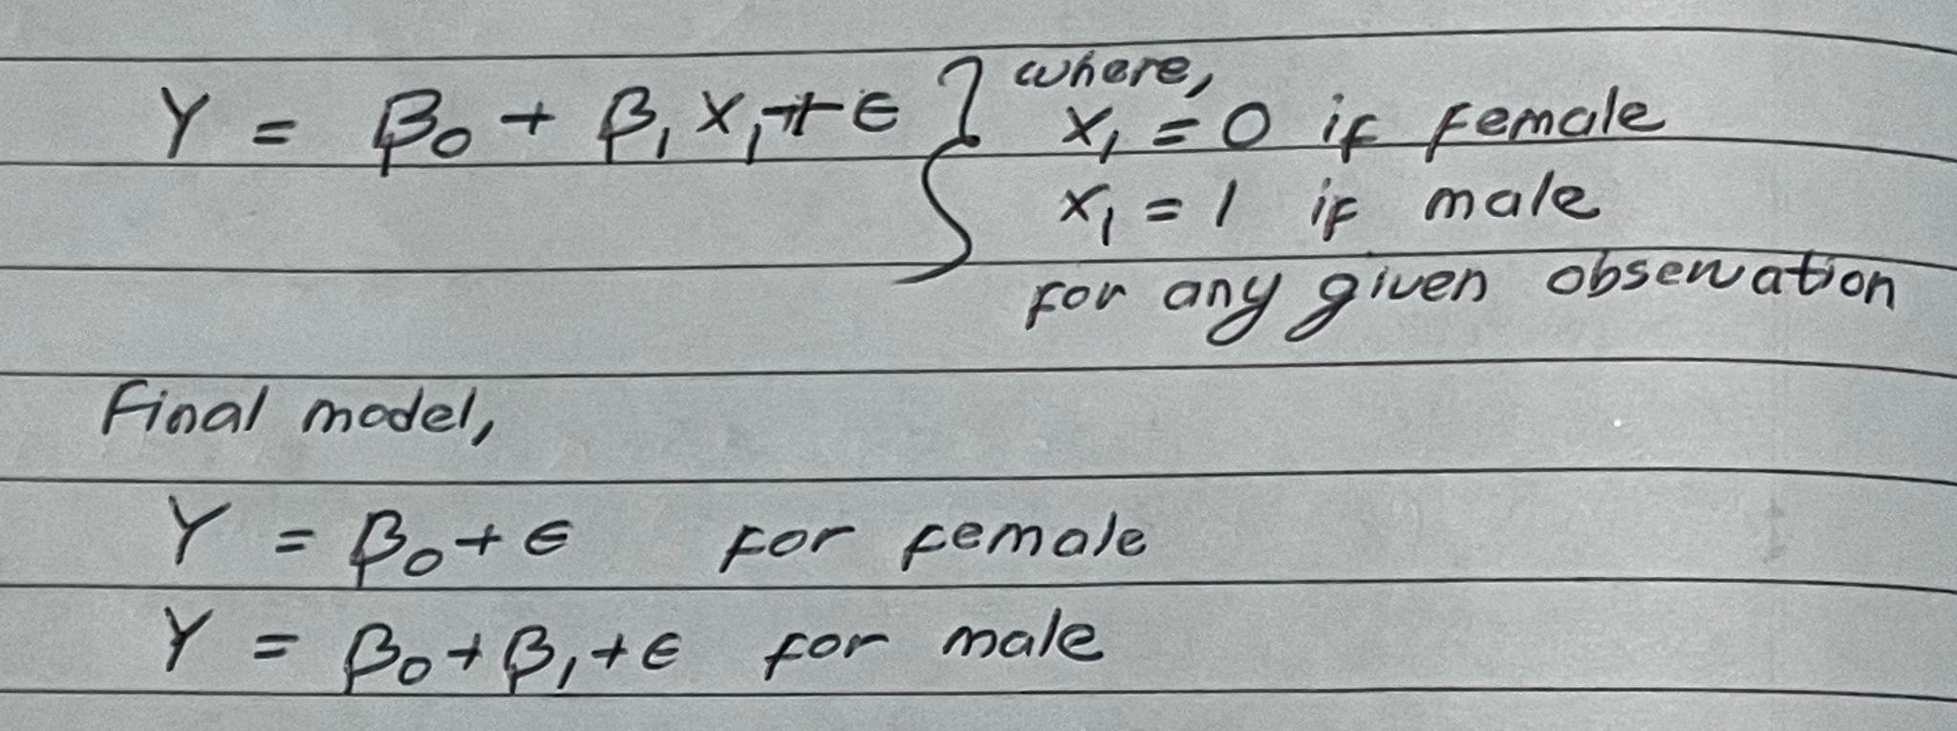

**Q.no.4.**

1. When λ = 0, the shrinkage penalty term becomes 0, then the whole equation will be equivalent to simply minimizing the Residual Sum of Squares (RSS). Answering in terms of bias-variance, variance increases steeply and bias decreases drastically.
2. When λ approaches infinity, the shrinkage penalty term heavily rewards coefficient that reaches towards 0 and consequently, all the coefficient in the regression model goes to 0 and the model essentially turns into a null model. Answering in terms of bias-variance, variance decreases greatly and bias increases drastically.
3. For selecting a good value of λ, we perform a process called cross validation. In it, we choose a grid of λ values and compute the cross-validation error for each value of λ. We then select the λ value for which the cross-validation error is the smallest. Finally, the model is re-fit using all of the available observations and the selected value of the tuning parameter (λ).

**Q.no.5.**

In all the answers below, an individual not defaulting (No) is taken as positive and an individual defaulting (Yes) is taken as negative.

1. Accuracy = $\frac{TP + TN }{TP + TN + FP + FN}$ = (9644 + 81) / (9644 + 81 + 252 + 23) = 0.9725 (97.25%)
2. Precision = $\frac{TP }{TP + FP }$ = (9644) / (9644 + 252) = 0.9745 (97.45%)
3. Recall = $\frac{TP }{TP + FN }$ = (9644) / (9644 + 23) = 0.9976 (99.76%)
4. F1 Score = $\frac{2 * Precision * Recall}{Precision + Recall}$ = (2 * 0.9745 * 0.9976) / (0.9745 + 0.9976) = 0.9859 (98.59%)